**Flavor Profile Research**

Specialty Coffee Association of America (SCAA) - Coffee Taster’s Flavor Wheel.

World Coffee Research - Sensory Lexicon - A tool for understanding and measuring coffee’s flavors and aromas.

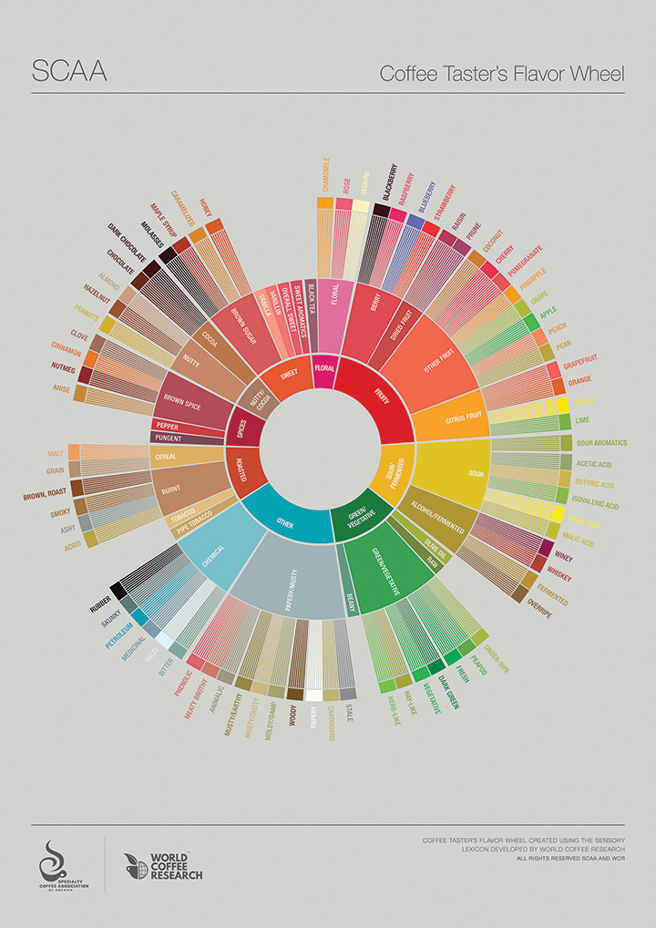  
  
**Sweet Aromatics**

* Vanillin
* Vanilla

**Fruity**

* Berry
  + Blackberry
  + Blueberry
  + Raspberry
  + Strawberry
* Stone Fruit
  + Peach
* Other Fruit
  + Apple
  + Cherry
  + Grapefruit
  + Orange
  + Pomegranate

**Floral**

* Chamomile
* Rose

**Spices**

* Brown Spice
  + Cinnamon
  + Clove
  + Nutmeg
* Other Spice
  + Anise
  + Black Pepper
  + Cardamom
  + Mace
  + Pepper

**Nutty**

* Hazelnut
* Peanut

**Bitter**

* Chocolate
  + Dark Chocolate
* Roasted
* Burnt

**Sour Aromatics**

* Acetic Acid
* Citrus First

**Other**

* Almonds
* Buttery
* Caramel
  + Caramelized Brown Sugar
  + Maple Syrup
* Chemical
* Fermented
  + Musty
* Gamey
* Hay-like
* Herbal
  + Green/Vegetative
* Malty
* Meaty Brothy
* Moldy/Damp
* Peppery
* Pipe Tobacco
* Smoky
* Stale
* Sweet
* Vegetative
  + Green/Vegetative

|  |  |
| --- | --- |
| **Category** | **Taste Attributes** |
| **Sour Aromatics** | Acetic Acid, Citric Acid, Malic Acid |
| **Sour** | Sour |
| **Bitter** | Bitter, Acrid, Ashy, Burnt, Pungent |
| **Sweet Aromatics** | Vanillin, Vanilla |
| **Sweet** | Sweet, Brown Sugar, Caramel, Caramelized, Honey, Maple Syrup, Molasses, Chocolate, Dark Chocolate, Overall Sweet |
| **Fruity** | Fruity, Apple, Berry, Blackberry, Blueberry, Cherry, Citrus Fruit, Grape, Grapefruit, Lemon, Lime, Orange, Other Fruit, Peach, Pear, Pineapple, Pomegranate, Prune, Raisin, Raspberry, Strawberry |
| **Floral** | Floral, Chamomile, Jasmine, Rose |
| **Spices** | Brown Spice, Cinnamon, Clove, Nutmeg, Anise, Black Pepper, Cardamom, Mace, Pepper, Other Spice |
| **Nutty** | Nutty, Almond, Hazelnut, Peanut |
| **Other** | Alcohol, Animalic, Beany, Black Tea, Blended, Body/Fullness, Butyric Acid, Cardboard, Cocoa, Coconut, Dark Green, Dried Fruit, Fermented, Fresh, Grain, Hay-like, Herb-like, Isovaleric Acid, Longevity, Malt, Meaty/Brothy, Medicinal, Metallic, Moldy/Damp, Mouth Drying, Musty/Dusty, Musty/Earthy, Oily, Olive Oil, Overripe/Near Fermented, Papery, Petroleum, Phenolic, Pipe Tobacco, Raw, Roasted, Rubber, Salty, Skunky, Smoky, Stale, Thick, Tobacco, Under-ripe, Vegetative, Whiskey, Winey, Wood |

|  |  |  |
| --- | --- | --- |
| **Category** | **Sub-category** | **Specifics** |
| **Fruity** | Citrus Fruit | Lemon, Lime, Orange, Grapefruit |
|  | Berry | Blackberry, Raspberry, Blueberry, Strawberry |
|  | Dried Fruit | Raisin, Prune |
|  | Other Fruit | Apple, Pear, Peach, Pineapple, Grape, Cherry, Pomegranate, Coconut |
| **Sour/Fermented** | Sour |  |
|  | Sour Aromatics | Acetic acid, Butyric acid, Isovaleric acid, Citric acid, Malic acid |
|  | Alcohol/Fermented | Whiskey, Winey, Fermented, Overripe |
| **Green/Vegetative** | Olive Oil |  |
|  | Raw |  |
|  | Green/Vegetative | Underripe, Peapod, Fresh, Dark Green, Vegetative, Hay-like, Herb-like |
| **Roasted** |  | Pipe tobacco, Tobacco, Burnt, Cereal, Grain, Malt |
| **Spices** | Pepper |  |
|  | Brown Spice | Clove, Cinnamon, Nutmeg, Anise |
| **Nutty/Cocoa** | Nutty | Peanut, Hazelnut, Almond |
|  | Cocoa | Chocolate, Dark Chocolate |
| **Sweet** | Brown Sugar | Molasses, Maple Syrup, Caramelized |
|  | Vanilla |  |
| **Floral** |  | Black Tea, Jasmine, Chamomile, Rose |
| **Other** |  | Paper, Stale, Musty, Earthy, Meaty, Animalic, Phenolic, Bitter, Salty, Medicinal, Petroleum, Skunky, Rubber |

Types of Charts for UI

* Sunburst
* Radar Chart